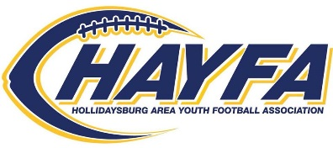
P.O. Box 96
Hollidaysburg, PA 16648
www.hayfa.us

PLEASE INCLUDE CONTACT INFORMATION BELOW AND SELECT YOUR CONTRIBUTION LEVEL.

BUSINESS NAME: ______________________________________________________________________________

CONTACT NAME: ______________________________________________________________________________

ADDRESS: ______________________________________________________________________________

PHONE: ______________________________________________________________________________

EMAIL: ______________________________________________________________________________

- HEISMAN CONTRIBUTOR- $500.00
Includes full page advertisement in all HAYFA Game Day Program Guides, banner prominently displayed at Tiger Stadium on game day every Saturday, sponsorship announced at games, and 2 End of year banquet tickets, company logo scrolling on HAYFA web-page as a HAYFA sponsor.

- LOMBARDI CONTRIBUTOR- $250.00
Includes half page advertisement in all HAYFA Game Day Program Guides, sponsorship announced at games

- OUTLAND CONTRIBUTOR- $100.00
Includes quarter page advertisement in all HAYFA Game Day Guides, and sponsorship announced at games

- TIGER FRIENDS- $50.00
Includes business card advertisement in all HAYFA Game Day Guides

Please return this form along with your contribution made payable to: HAYFA Enclosed you will find a self-addressed envelope.

Also, please include your advertisement for the HAYFA Game Day Guide, your Ad may be emailed directly to: Ken Smith – hayfa.org@gmail.com

THANK YOU FOR YOUR SUPPORT!!!

